**Name:** Riya Sharma

**Data:** [**https://finance.yahoo.com/quote/ADMP/**](https://finance.yahoo.com/quote/ADMP/)

**GITHUB:** [**https://github.com/riyasharma28463/Assignment1**](https://github.com/riyasharma28463/Assignment1)

**Visualization 1: Stock Price Over Time Using Line Plot**

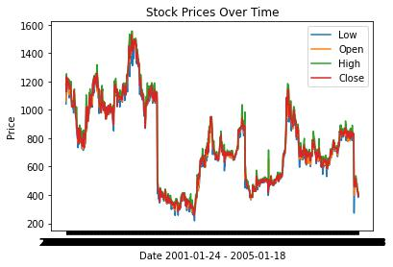

Line plots are useful for depicting the correlation between the two variables. The stock price of "Adamin Pharmaceuticals Corporation" is depicted as a line plot against time in our first visualization. The x-axix belongs to time and y-axis belongs to stock price. Due to large number of values y-axis values in the data set the line plot diagram showing it to be black. According to presented data set of the Adamin Pharmaceuticals Corporation, after 2003, the stock price dropped and within a half year it had reached the market value, although not at the high. The maximum stock price achieved during the first half period of the presented data set.

**Visualization 2: Stock Price Over Time Using Scattered Plot**

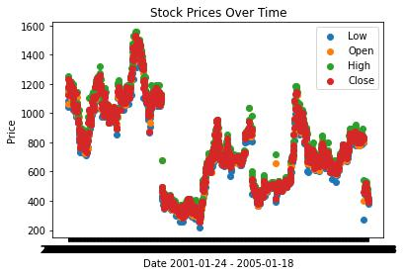

The scattered graph depicts the relationship between the two variables, which in our instance are stock price and time. The correlation is illustrated by the scatter plot. The scatter plot shown in the figure 2 depicts the trend of the pharmaceutical corporation’s stock price from 2001 to 2005. The graph demonstrates how the stock price initially peaked in the early years, fell, and then increased as the

company performed better in terms of market value during the years of 2004. The presented scattered graph also depicting the company growth and market confidence towards the company as corporation regains the market confidence after their major crash in around 2003. When looking at the company's growth and market worth as a whole, the pharmaceutical giant is on the upward.

**Visualization 3: Histogram of the Stock Market Price Close**

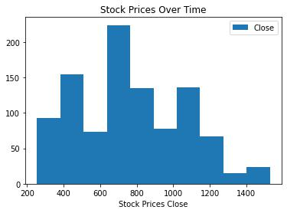

A histogram can provide a quick way to view the distribution of a dataset, allowing you to find patterns and outliers in the data. A histogram is a bar graph-like depiction of data that bins a range of classes into columns along the horizontal x-axis. The vertical y-axis displays the numerical count or percentage of occurrences in the data for each column. Columns can be used to visualize patterns in data distributions. Closing price is the last price at which a share traded during the regular trading day which is the benchmark used by the investor to gauge the performance of the company. The histogram of the closing stock price by considering the different price range indicates the high trend over the value at the price range of 400 to 1100.